**COSMETICS STORE MANAGEMENT**

Developed By:

**Jahnavi Siddavaram**

Gmail : jahnavis3110@gmail.com

**Sree Vidyanikethan Engineering College**

**Department of CSSE BTECH- IV year**

**Branch – CSBS**

**21121A2940**

**ABSTRACT**

The Cosmetics Store Management project aims to streamline and automate the operations of a cosmetics store using Salesforce CRM. This project focuses on managing customer data, product inventories, sales processes, and customer service to enhance business efficiency and improve customer satisfaction. Key functionalities include tracking product stock levels, automating order processing, managing customer relationships, and facilitating service requests for returns and complaints.

By utilizing custom objects, workflows, and integrations, the project will provide a comprehensive solution for inventory management, order fulfillment, and personalized customer interactions. Salesforce's reporting tools and dashboards will offer insights into sales performance, stock status, and customer trends. This implementation will optimize the store’s processes, increase productivity, and enable better decision-making through data-driven strategies, while offering seamless customer service and operational management.

**INDEX PAGE**

|  |  |  |
| --- | --- | --- |
|  | **INDEX PAGE** |  |
| **TOPICS** |  | **PAGES** |
| 1.Creation salesforce org |  | 04-07 |
| 2.Object |  | 08-14 |
| 3.Fields And RelationShip |  | 15-20 |
| 4.Page Layouts |  | 21-22 |
| 5.The Lightning App |  | 23-25 |
| 6.Profile |  | 26-28 |
| 7.Setup Roles |  | 29-31 |
| 8.Users |  | 32-35 |
| 9.User Adaption |  | 36-38 |
| 10.Import Data |  | 39-42 |
| 11.What Are Reports? |  | 43-47 |
| 12.Dashboards |  | 48-51 |

**1.Creation Salesforce Org**

# Logging into SmartInternz Skill Wallet:

* + 1. **Visit**
    2. **The SmartInternz website**: Go to [SmartInternz.](https://smartinternz.com/)
    3. **Locate the Login Option**: On the homepage, find the login or sign-inoption.
    4. **Use your credentials**: Enter the email and password you registered with. If you're using a platform-linked account (e.g., Google, LinkedIn), use the corresponding option to sign in.
    5. **Navigate to the SkillWallet**: After loggingin, go to your dashboard or profile section where you should find "Skill Wallet" or "Guided Projects" listed.

# Accessing Guided Projects:

* + 1. Afterlogging in, navigateto the "Guided Projects" tab or sectionon the SmartInternz platform.
    2. Here,you should be ableto see any projects you’vebeen assigned or those you’ve enrolled in.
    3. Click on any projectto view the details, guidelines, and resources you need to complete it.

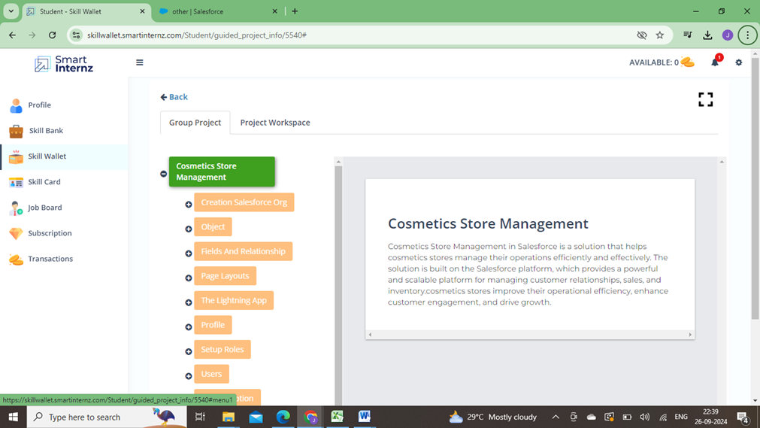

# 1.3.Creating Developer Account

Creating a developer org in salesforce.

* + 1. Go to [developers.salesforce.com/signup.](https://developer.salesforce.com/signup)
    2. Click on sign up.
    3. On the sign up form, enterthe following details:
       1. First name & Last name
       2. Email
       3. Role : Developer
       4. Company : College Name
       5. County : India
       6. Postal Code : pin code
       7. Username : should be a combination of your name and company.

This need not be an actual email id, you can give anything in the format : [username@organization.com](mailto:username@organization.com)

Click on sign up after filling these.

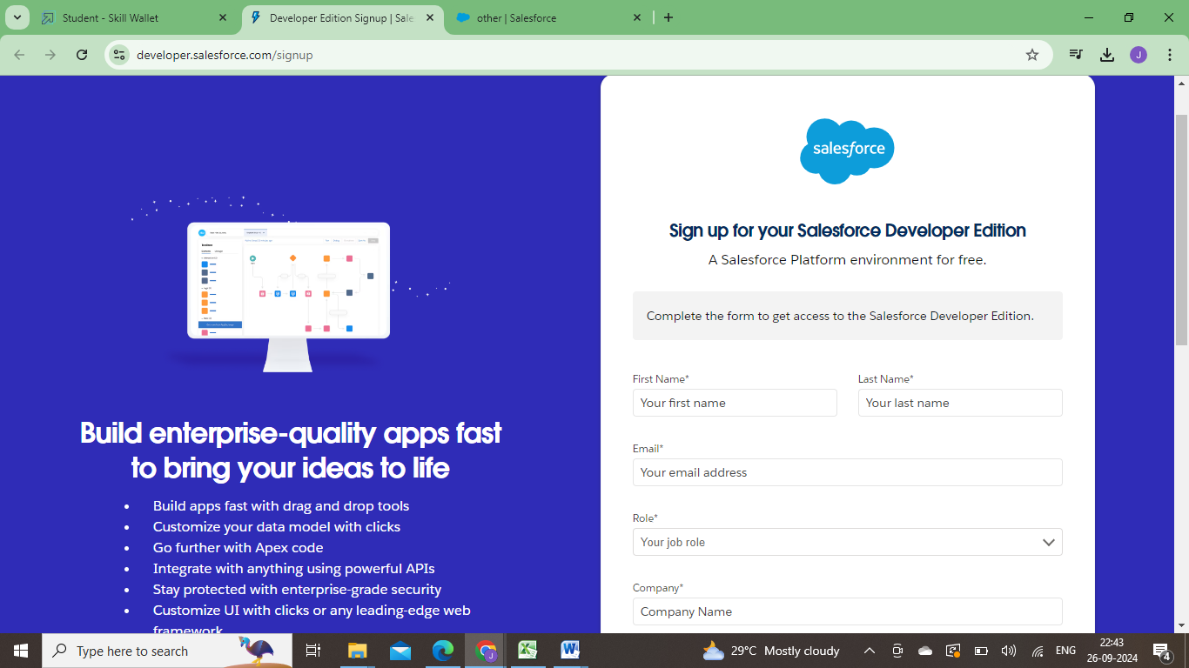

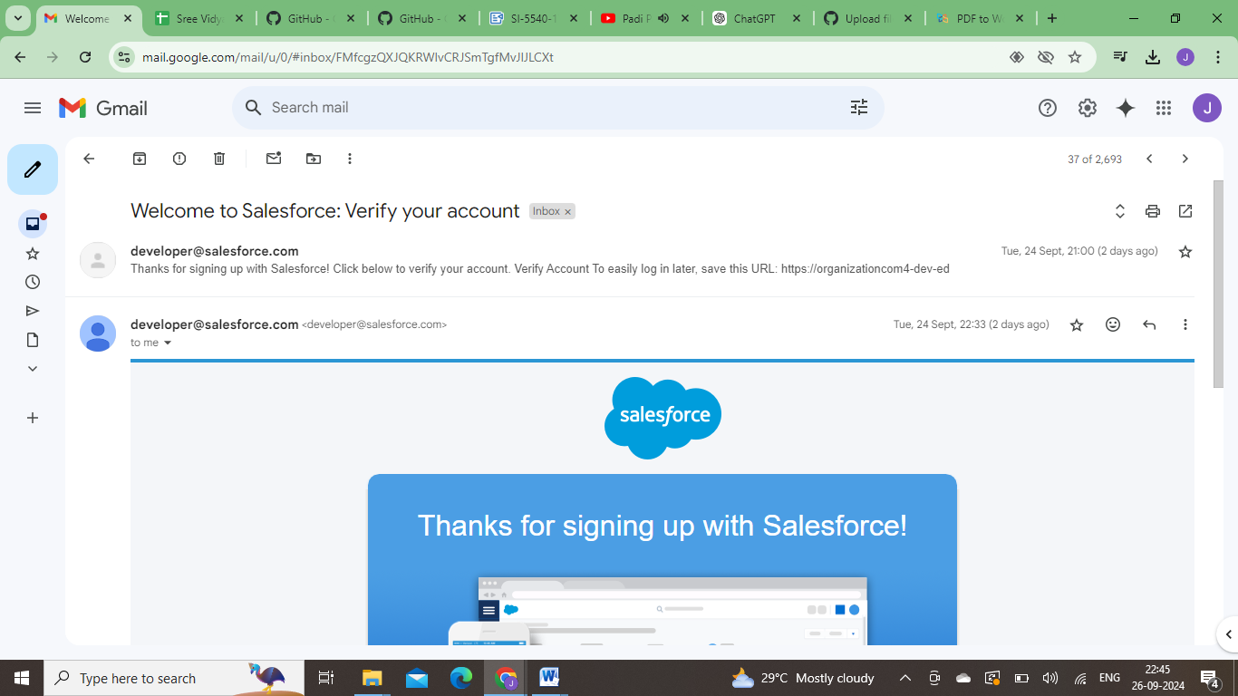

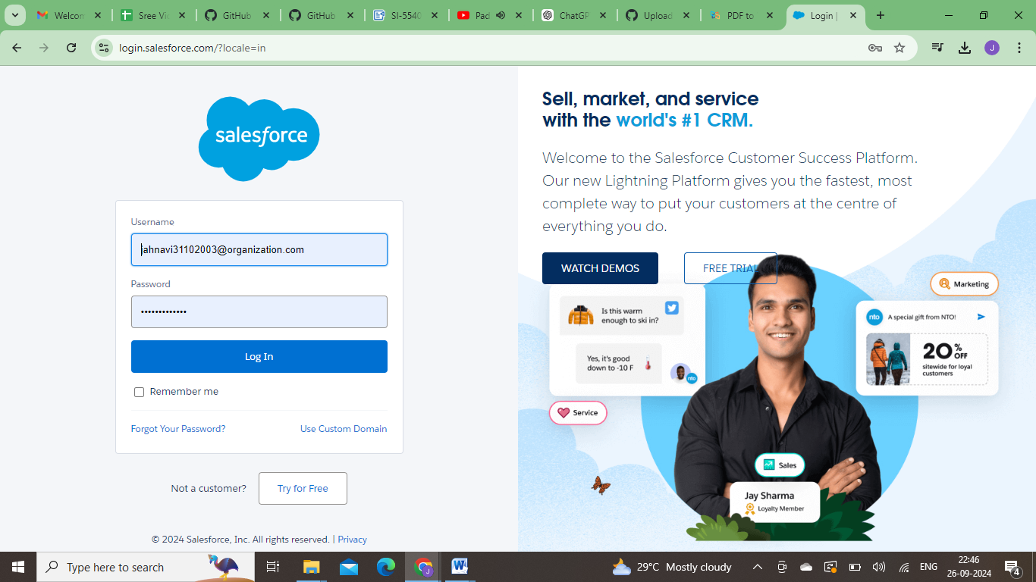

**2.Object**

Salesforce objects are database tables that permit you to store data that is specific to an organisation. Salesforce objectsare of two types: StandardObjects: Standard objectsare the kind of objects that are provided by salesforce.com such as users, contracts, reports, dashboards, etc.

Custom objects :Our Customers, Consultants, Retailers, Others.

# 2.1.To Create an object:

To Create an object:

Creation of Objectsfor Urban Color,For this Urban Color we need to create 3 objects

i.e .,Our Customers, Consultants, Retailers, others.

The below steps will assist you in creating thoseobjects.

* Click on the gear icon and then select Setup.
* Click on the object manager tab just beside the home tab.
* Afterthe above steps, have a look onthe extreme right you will find a Create Dropdown click on that and select Custom Object.
* Creation of Our Customer Object

Onthe Custom ObjectDefinition page, create the object as follows:

* Label: Our Customer
* Plural Label: Our Customers
* Record Name: Our Customer
* Check the AllowReports checkbox
* Check the Allow Search checkbox
* Click Save.
* Now create a custom tab. Click the Home tab, enter Tabs in QuickFind and selectTabs.
* Under Custom ObjectTabs, click New.
* For Object, selectOur Customer.
* For Tab Style, select any icon.

Leave all defaults as is. ClickNext, Next, and Save

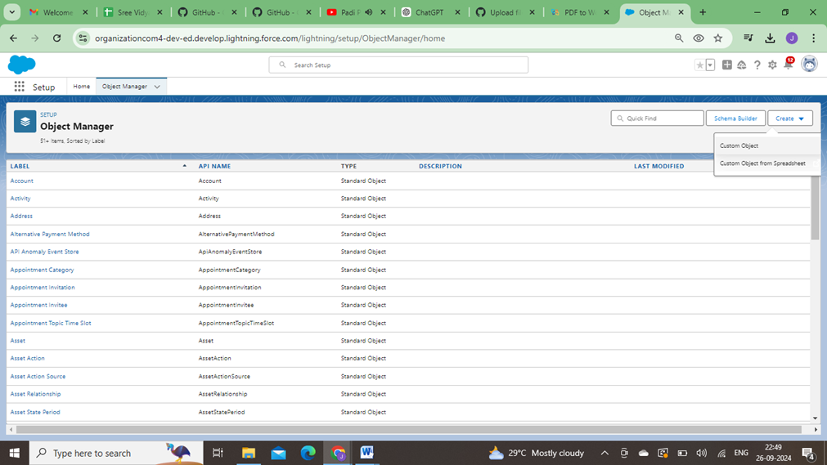

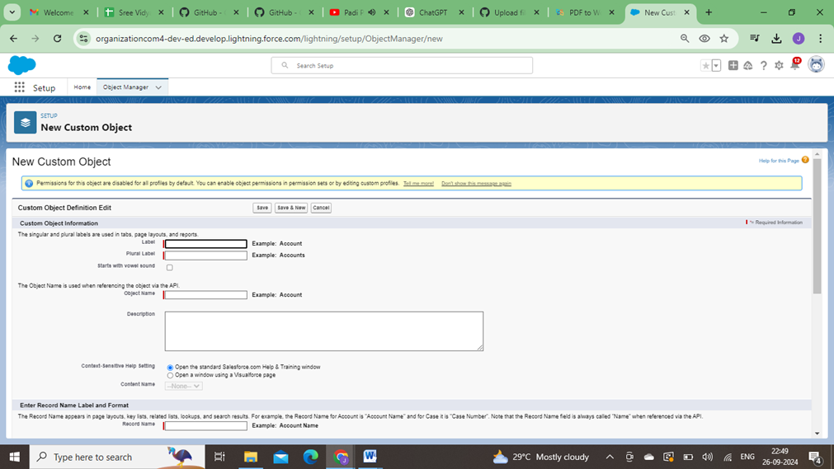

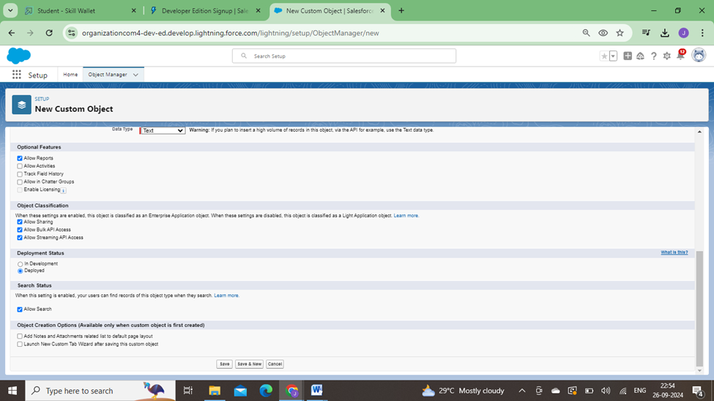

# 2.2.Consultants Object

The below steps will assist you in creating thoseobjects.

* + - Click on the gear icon and then select Setup.
    - Click on the object managertab just besidethe home tab.
    - After the above steps, have a look on the extreme right you will find a Create Dropdown click on that and select Custom Object.
    - Creation of Consultant Object

On the Custom ObjectDefinition page, create the object as follows:

* + - Label: Consultant
    - Plural Label: Consultants
    - Record Name: Consultants
    - Check the Allow Reports checkbox
    - Check the Allow Search checkbox
    - Click Save.
    - Now create a custom tab. Click the Hometab, enter Tabs inQuick Find and select Tabs.
    - Under Custom ObjectTabs, click New.
    - For Object, select Consultants.
    - For Tab Style,select any icon.
    - Leave all defaultsas is. Click Next, Next, and Save.

# 2.3.Retailers objectcreation

To Createan object:

The below steps will assist you in creatingthose objects.

* + - Click on the gear icon and then select Setup.
    - Click on the object managertab just besidethe home tab.
    - After the above steps, have a look on the extreme right you will find a Create Dropdown click on that and select Custom Object.
    - Creation of RetailerObject

On the Custom ObjectDefinition page, create the object as follows:

* + - Label: Retailer
    - Plural Label: Retailers
    - Record Name: Retailers
    - Check the Allow Reports checkbox
    - Check the Allow Search checkbox
    - Click Save.
    - Now create a custom tab. Click the Hometab, enter Tabs inQuick Find and select Tabs.
    - Under Custom ObjectTabs, click New.
    - For Object, selectRetailers.
    - For Tab Style,select any icon.
    - Leave all defaultsas is. Click Next, Next, and Save.

# 2.4.Others Object Creation

To Createan object:

The below steps will assist you in creatingthose objects.

* + - Click on the gear icon and then select Setup.
    - Click on the object managertab just beside the home tab.
    - After the above steps, have a look on the extreme right you will find a Create Dropdown click on that and select Custom Object.
    - Creation of others Object

On the Custom ObjectDefinition page, create the object as follows:

* + - Label: other
    - Plural Label: others
    - Record Name: others
    - Check the Allow Reports checkbox
    - Check the Allow Search checkbox
    - Click Save.
    - Now create a custom tab. Click the Hometab, enter Tabs inQuick Find and select Tabs.
    - Under Custom ObjectTabs, click New.
    - For Object, selectothers.
    - For Tab Style,select any icon.
    - Leave all defaults as is. Click Next, Next, and Save

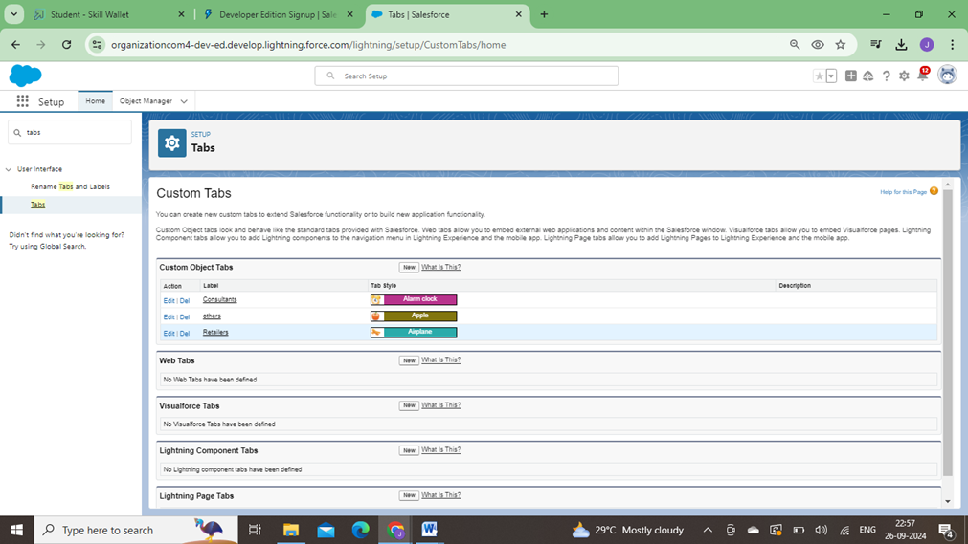

**3.Fields and Relationship**

An object relationship in Salesforce is a two-way association between two objects. Relationships are createdby creating customrelationship fields on an object. This is done so that when users view records, they can also see and access related data.

# 3.1.Fields in Our Customers objects

Fields in Our Customers objects follow belowdata types:

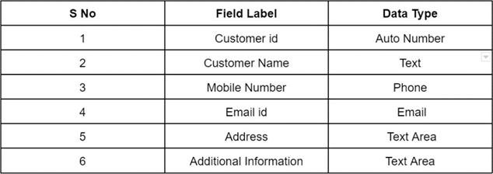

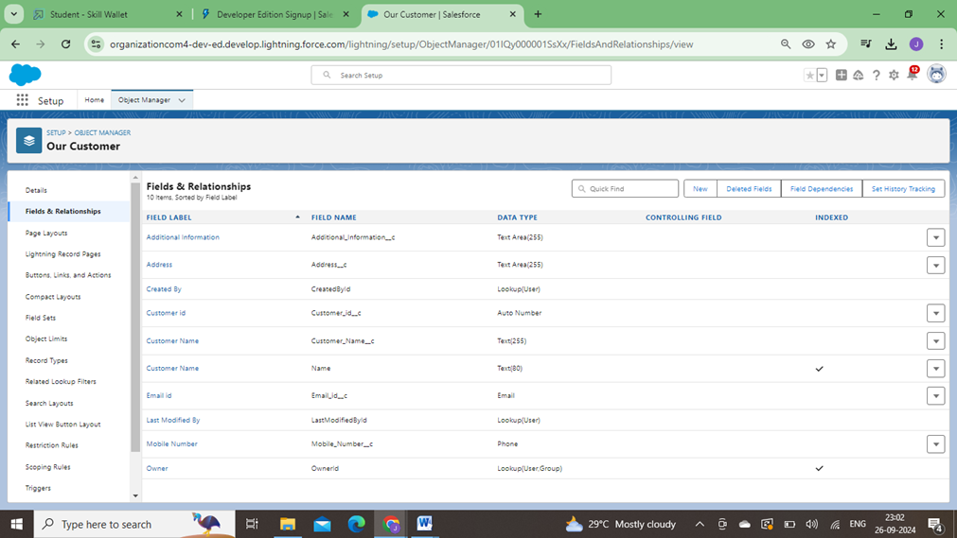

# 3.2.Fields in Consultants objects

Fields in Consultants objects follow below data types:

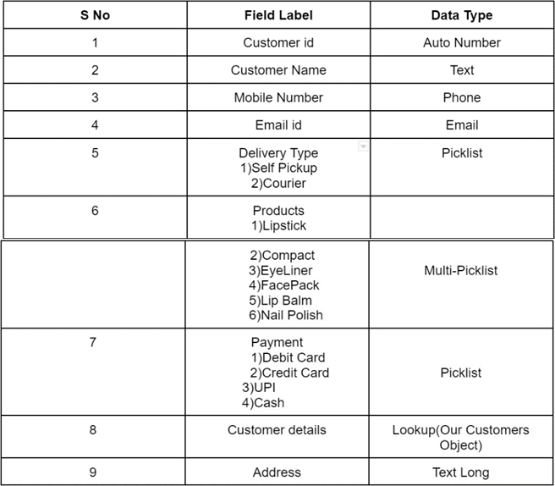

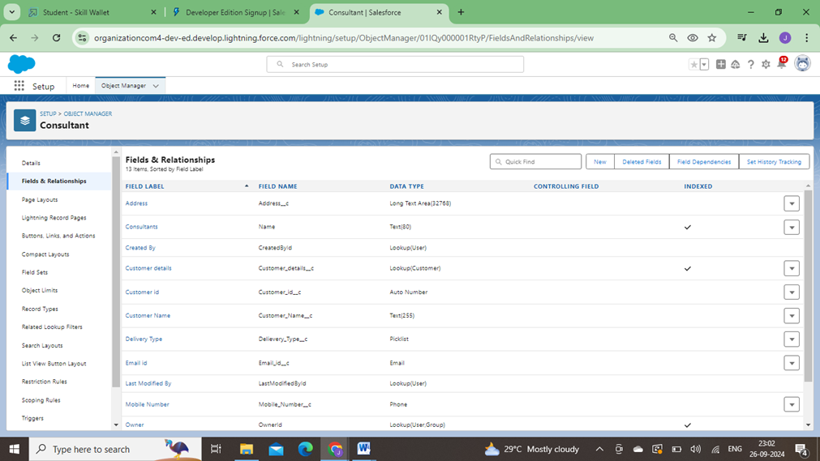

# 3.3.Fields in Retailers objects

Fields in Retailers objectsfollow below data types:

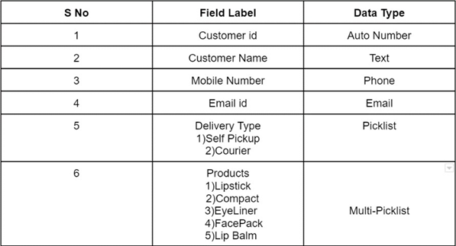

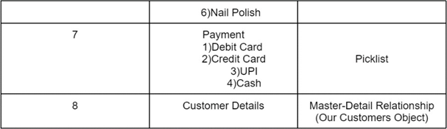

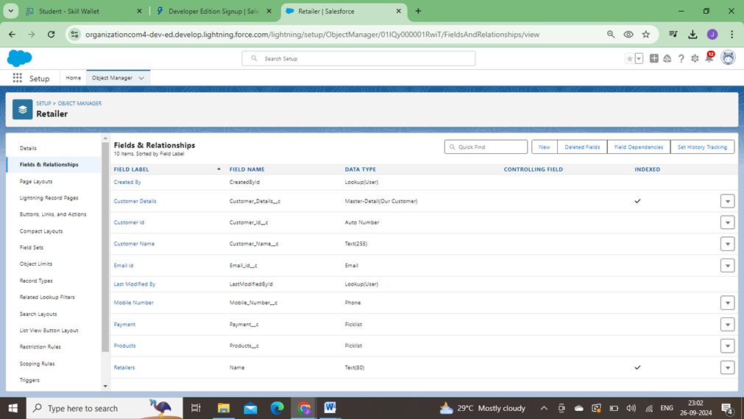

# 3.4.Fields in Others objects

Fields in Others objects follow below data types:

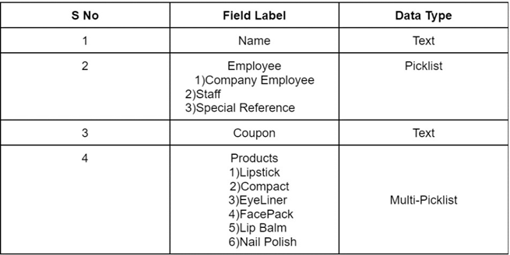

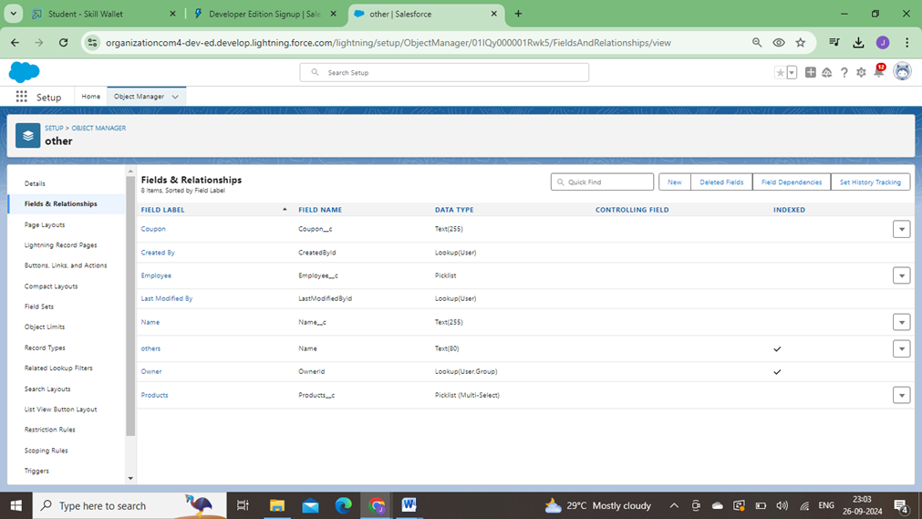

**4.Page Layouts**

In Salesforce, page layouts define the organisation and arrangement of fields, buttons, related lists, and other components on an object's detail and edit pages.They allow you to control the user interface and tailor it to meet the specific needs of your organisation.

# 4.1.Page Layout Creation

* 1. From the Salesforce setup menu, go to "Object Manager" and select the Consultants object.
  2. Click on "Page Layouts" in the left sidebar.This will displaya list of available page layouts for the selected object.
  3. Select the Consultant Layout page layout

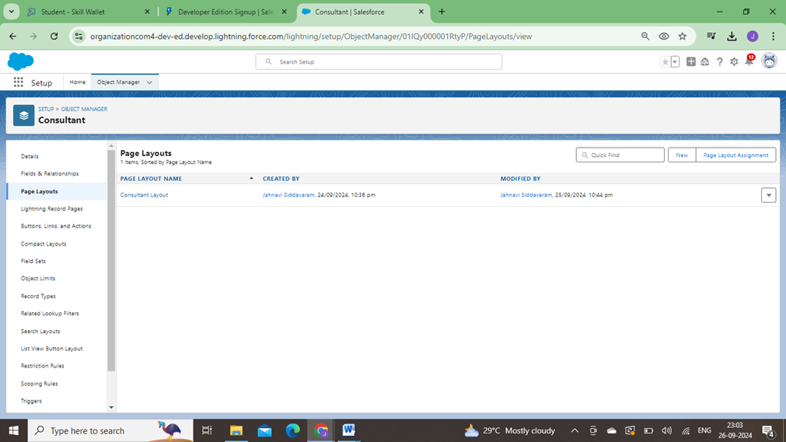

4. Click And Drag Deliverytype and AddressFields Below Phone field.

5. Click on Save.

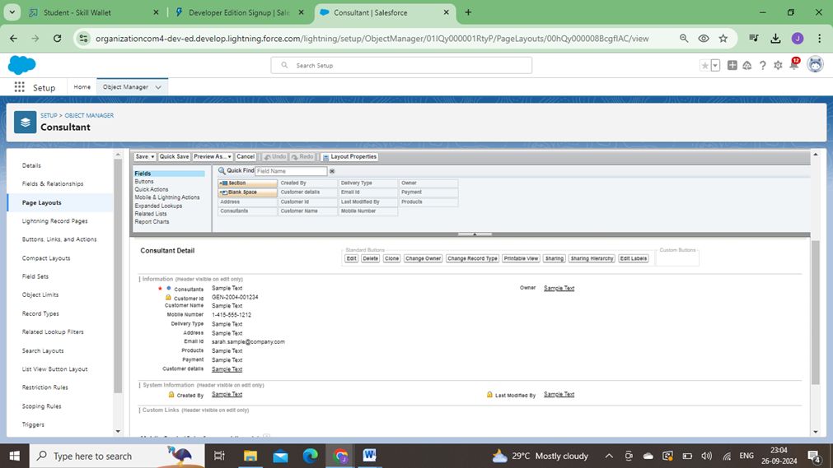

**5.The LightningApp**

An app is a collection of items that work together to serve a particular function. In Lightning Experience, Lightning apps give your users access to sets of objects,tabs, and otheritems all in one convenient bundle in the navigation bar.

Lightning apps letyou brand your apps with a custom Color and logo. You can even include a utility bar and Lightning page tabs in your Lightning app. Members of your org can work more efficiently by easily switching between apps.

# 5.1.Create a Lightning App

To createa lightning app page:

1.Go to setup page -->search “app manager”in quick find --> select “app manager” --> click on New lightning App.

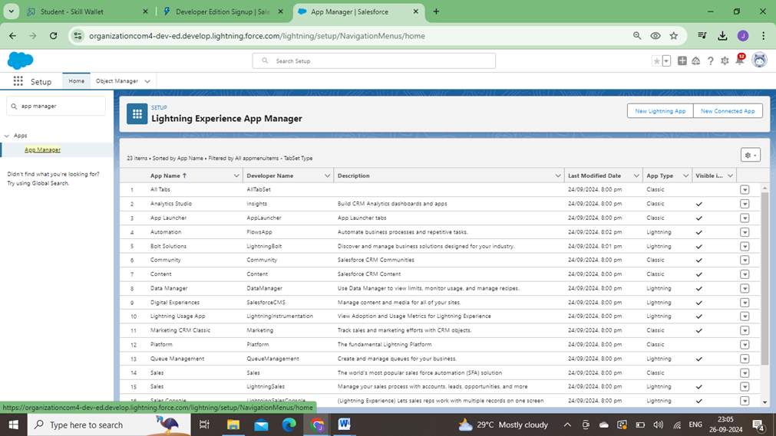

2.Fill the app name as Urban Color in app detailsand branding --> Next --> (App option page) keep it as default --> Next --> (Utility Items) keep it as default --> Next

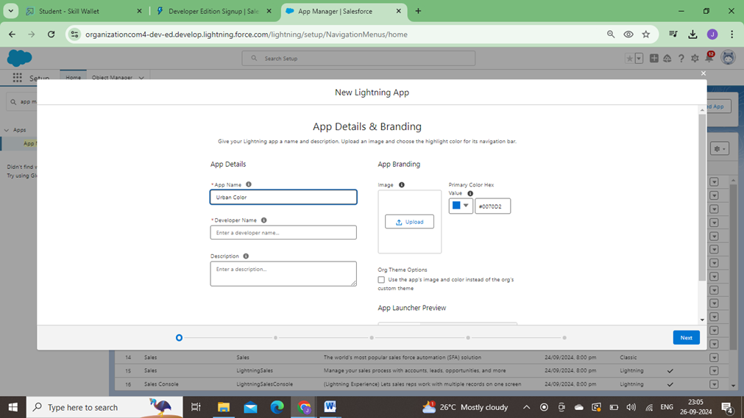

3.To Add Navigation Items.

4.Select the items (Our Customers,Consultants,Retailers,Others,Reports,Dashboards ) from the search bar and move it using the arrow button --> Next.

5.To Add User Profiles:

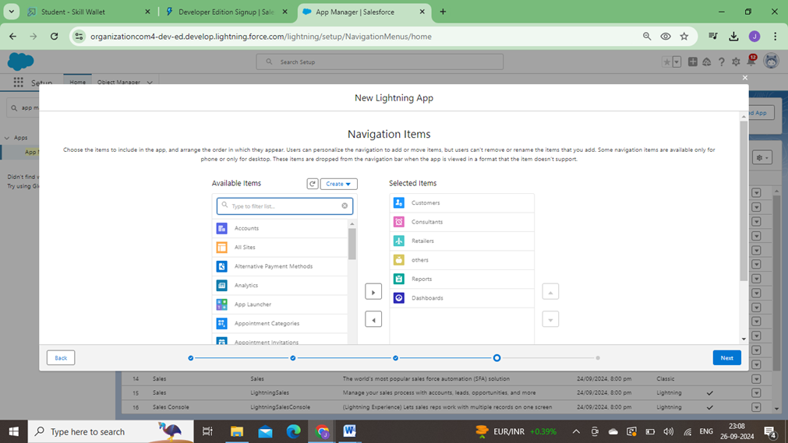

6.Search profiles (Systemadministrator) in the search bar --> click on the arrow button-> save & finish.

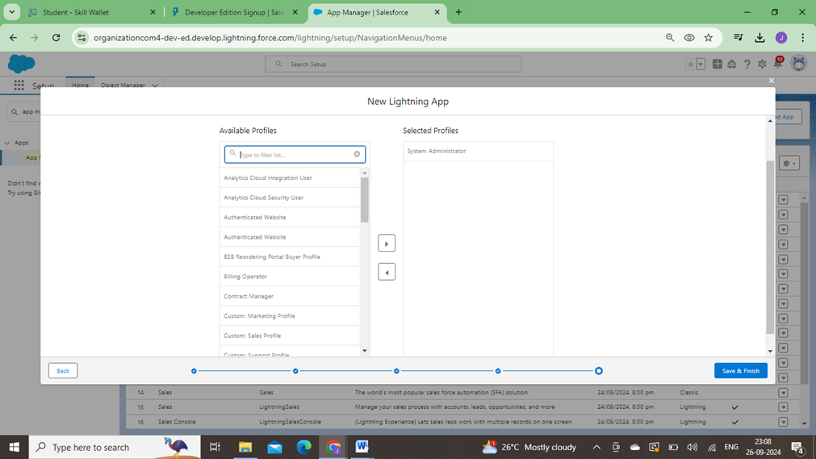

**6.Profile**

A profile is a group/collection of settings and permissions that define what a user can do in salesforce. A profile controls “Objectpermissions, Field permissions, User permissions, Tab settings, App settings, Apex class access, Visualforce page access, Page layouts, Record Types, Login hours & Login IP ranges.

# 6.1.Creating a Profiles

Creating a Profiles: Now create a Store Supervisor profile and set its object permissions. Creating a Profiles:

Now create a Store Supervisor profile and set its objectpermissions.

* From Setup enterProfiles in the Quick Find box, and select Profiles.
* From the list of profiles,find Standard User.
* Click Clone.
* For Profile Name, enter StoreSupervisor.
* Click Save.
* While still on the StoreSupervisor profile page, then click Edit.
* Scroll down to Custom ObjectPermissions and give access for Create,Read,Edit,Delete,View all and modify all for Our Customers,Consultants,Retailers,Others.
* Scroll down to Custom App Settings and give accessfor Urban Color.

To createa new profile:

1. Go to setup --> type profiles in quick find box --> click on profiles --> clonethe desired profile (standard user is preferable) --> enter profile name --> save.

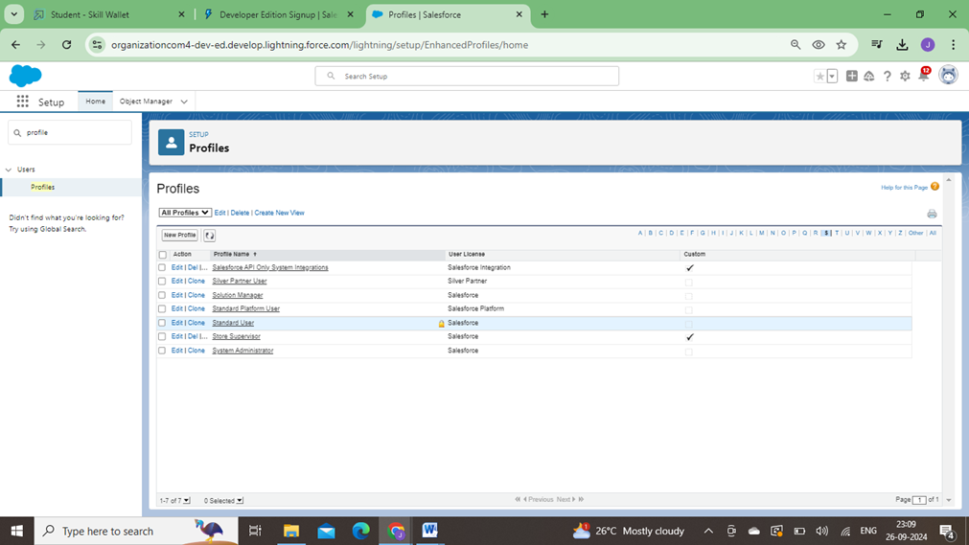

2. Scroll down to the Custom objectpermission and give all access to the Consultants, Others, Our Customers, Retailers object.

3. Click on Save.

4. Similarly Create operator profile,Clone Salesforce Platformuser and give access only for Billing Operator.

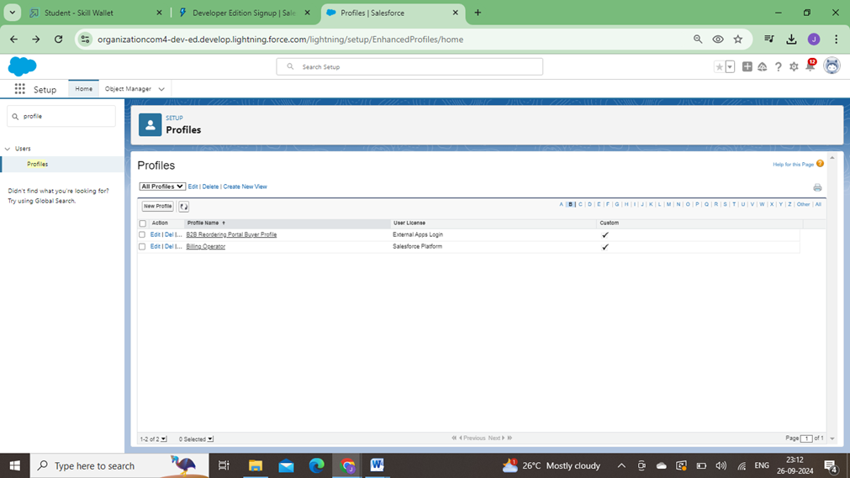

**7.Setup Roles**

Roles are record-level accesscontrols that define what data a user can see in Salesforce.

# 7.1.Setup Roles

1. Click on the Gear Icon
2. Click "Setup"
3. In the Quick Find box,enter "Roles"
4. Click "Roles"
5. Click on "Set Up Roles"
6. Click "Expand All"
7. Under the CEO,click on "AddRole"
8. Fill up the Label as Store Head, Role Name Store_Head.
9. Enter a Role name that will be displayed on Reports
10. Click on Save .

Similarly createOne Roles underStore Head as Billing Operator.

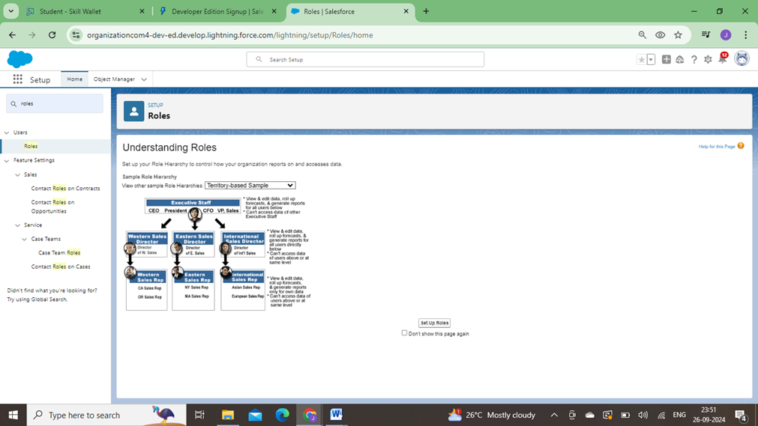

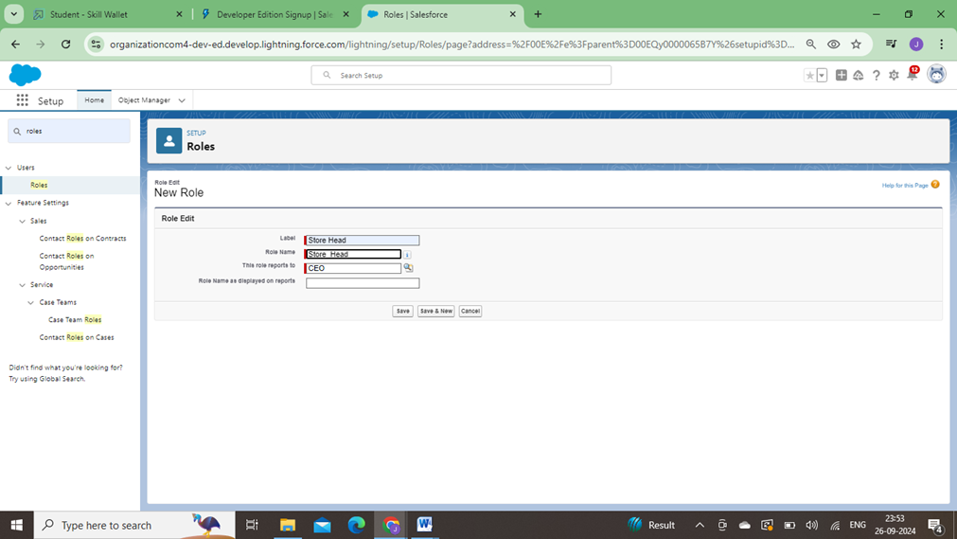

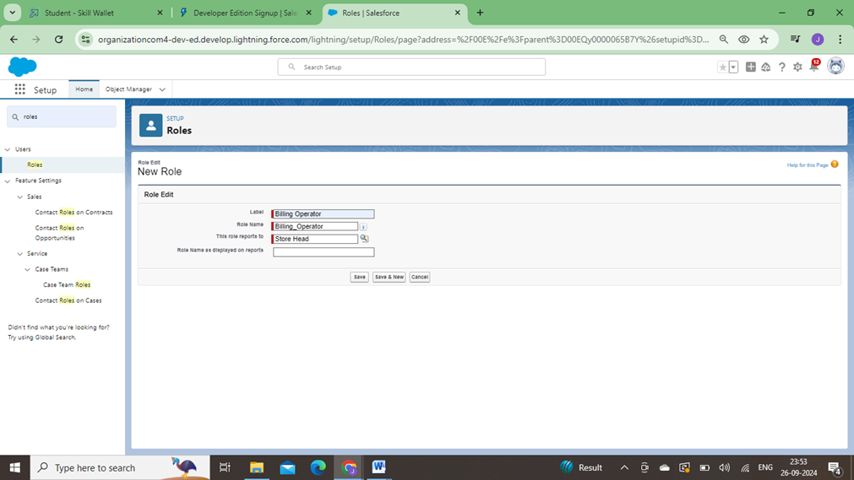

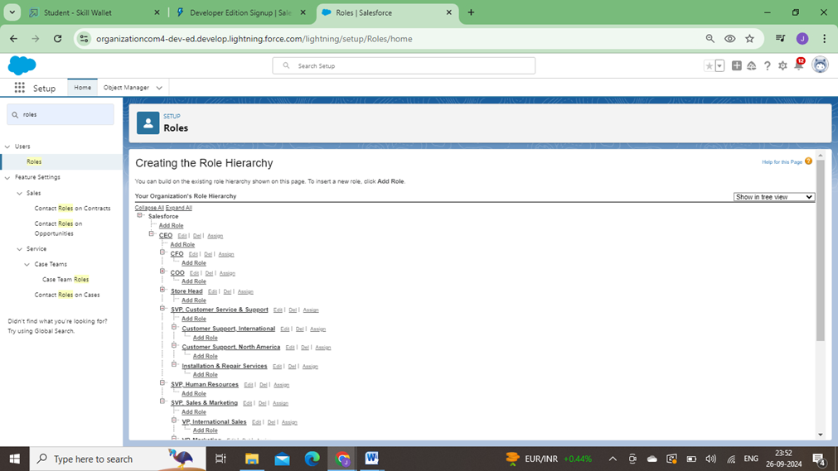

**8.Users**

A user is anyone who logs in to Salesforce. Users are employees at your company,such as sales reps, managers, and IT specialists, who need accessto the company's records. Every user in Salesforce has a user account.

# 8.1.Creating a Users:

* + 1. From Setup, in the Quick Find box, enter Users, and then select Users.
    2. Click New User.
    3. Enter the user’sname Amar K and (Your)email address and a uniqueusername in the form of an email address. By default, the username is the same as the email address.
    4. Select a Role(Store Head)
    5. Select a User Licence As Salesforce.
    6. Select a profileas Store Supervisor.
    7. Check Generatenew password and notify the userimmediately to have the user’s login name and a temporary password emailed to your email.

Fill in the fields(first name, last name, alias,email id, username, nick name, role, user licence, profiles) --> save.

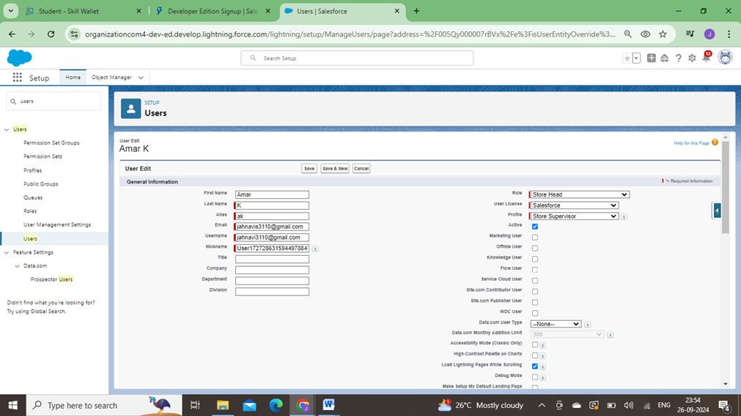

# 8.2.Second User Creation

* 1. From Setup, in the Quick Find box, enter Users, and then select Users.
  2. Click New User.
  3. Enter the user’sname John Teddy and (Your)email address and a uniqueusername in the form of an email address. By default, the username is the same as the email address.
  4. Select a Role(Billing Operator)
  5. Select a User Licence As Salesforce Platform.
  6. Select a profileas Billing Operator.
  7. Check Generate new password and notify the userimmediately to have the user’s login name and a temporary password emailed to your email.

Fill in the fields(first name, last name, alias,email id, username, nick name, role, user licence, profiles) --> save.

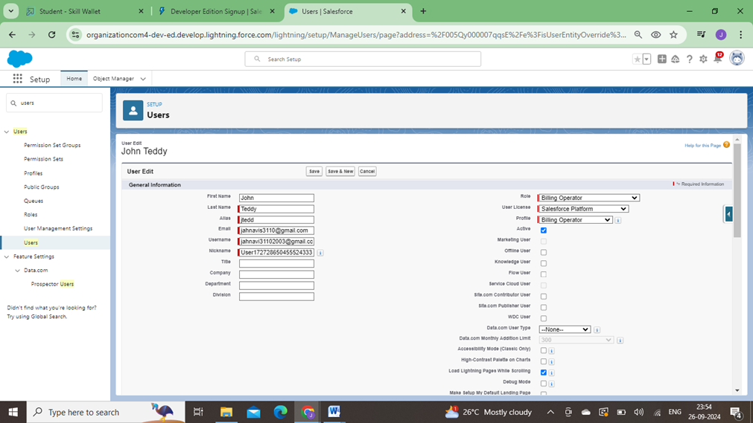

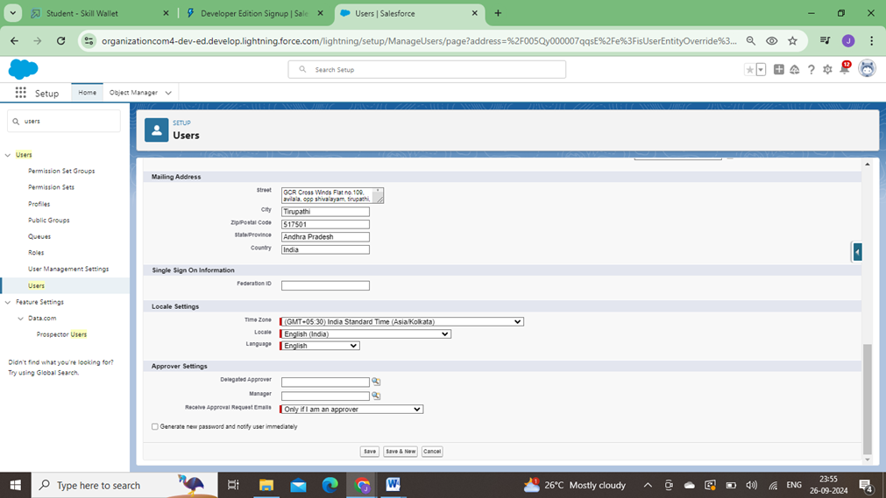



**9.User Adoption**

We need to understand user adoption and navigation. How to interactwith database and their records.

# 9.1.Create Our Customer Record

* + 1. Click on App Launcher on left side of screen.
    2. Search Urban Color& click on it.
    3. Click on Our Customer tab.
    4. Click new button
    5. Fill all Our Customer record details.
    6. Click on Save Button

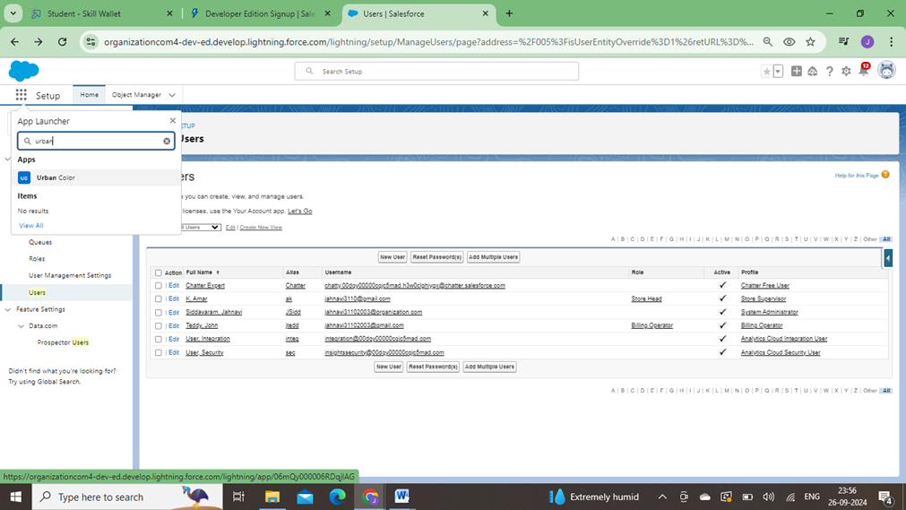

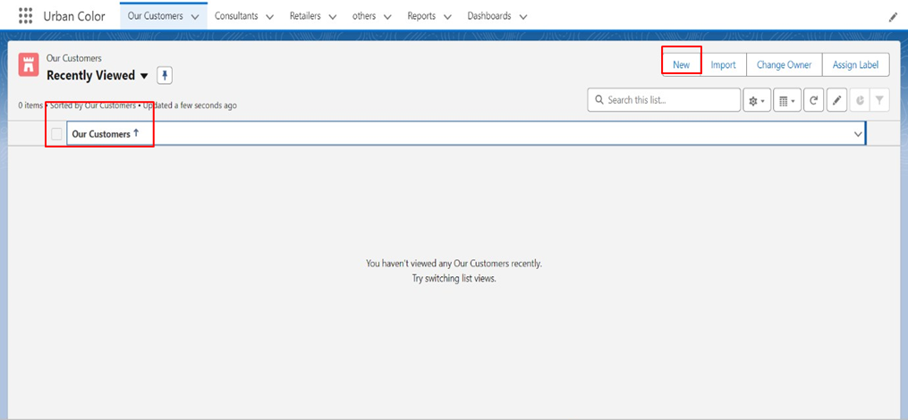

# 9.2.View Record (Our Customer)

View Record(Our Customer):

* + 1. Click on App Launcher on the left side of the screen.
    2. Search Urban Color& click on it.
    3. Click on Our Customer Tab.
    4. Click on any record name.you can see the details of the Our Customer.

# 9.3.Delete Record (Our Customer)

Delete Record(Our Customer):

1. Click on App Launcheron the left side of the screen.

2. Search Urban Color & click on it.

3. Click on Our CustomerTab.

4. Click on Arrow at right hand side on that Particular record.

5. Click delete and delete again

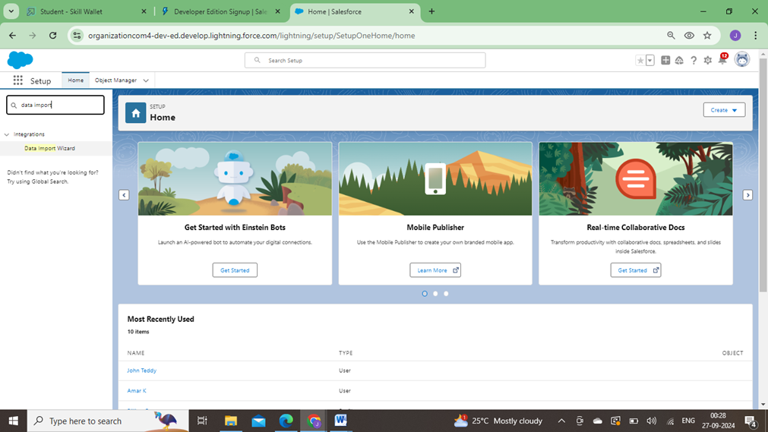

**10.Import Data**

Data ImportWizard—this tool, accessible through the Setup menu, lets you import data in common standard objects, such as contacts, leads, accounts, as well as data in custom objects.

# 10.1. To Import Data

* + 1. From Setup, click the Home tab.
    2. In the Quick Find box, enter Data Import and select Data Import Wizard
    3. Click Launch Wizard!

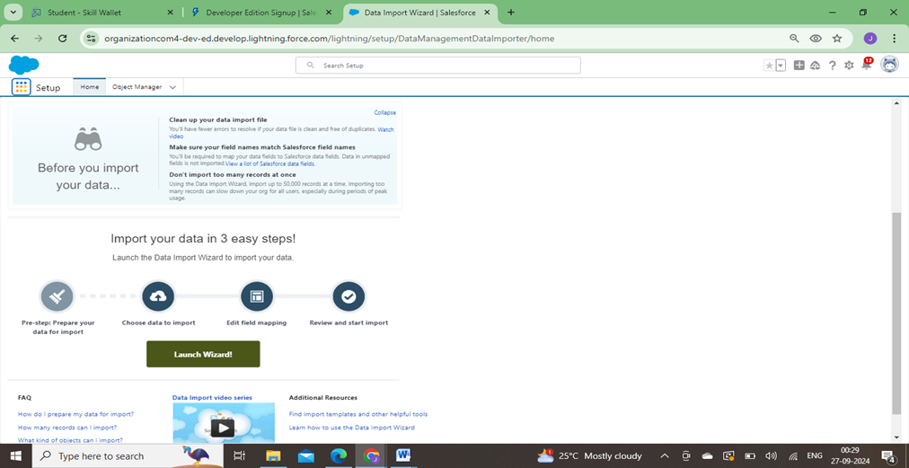

4. Click the CustomObjects tab and select the Consultant object

5. Select Add new records

6. Click CSV and choosefile Consultant_CSV which we made earlier. ClickNext

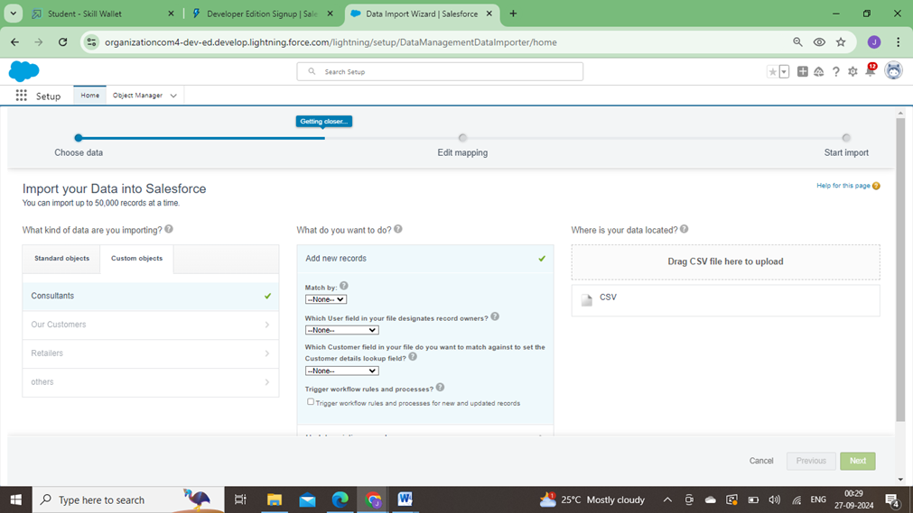

7. Since the field names in the CSV file (CSV Header) are the same as the field names in your object (Mapped Salesforce Object), the fields are automatically mapped. Click Next

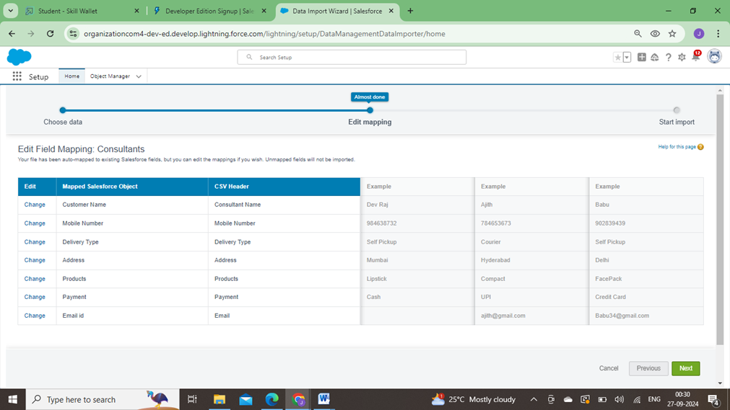

8. The next screengives you a summary of your data import. Click Start Import.

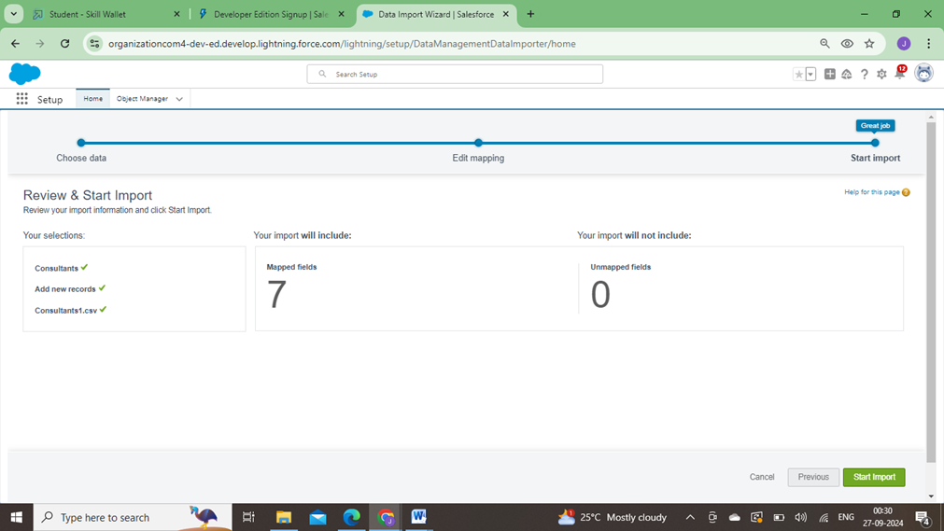

9. Click OK on the popup

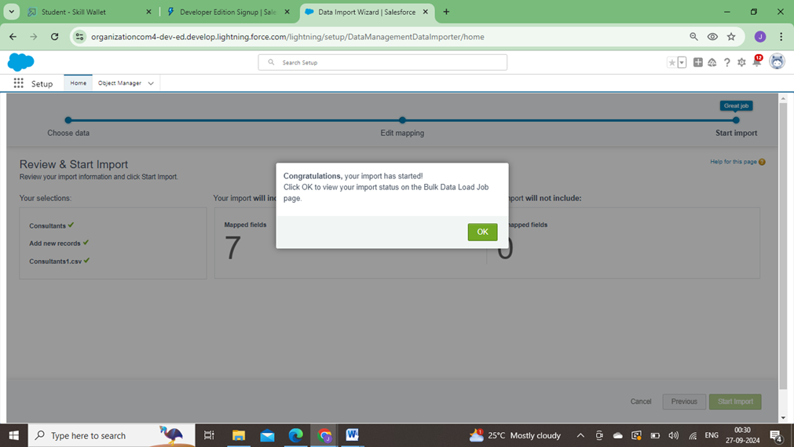

10. Scroll down the page and verify that your data has been imported underbatches

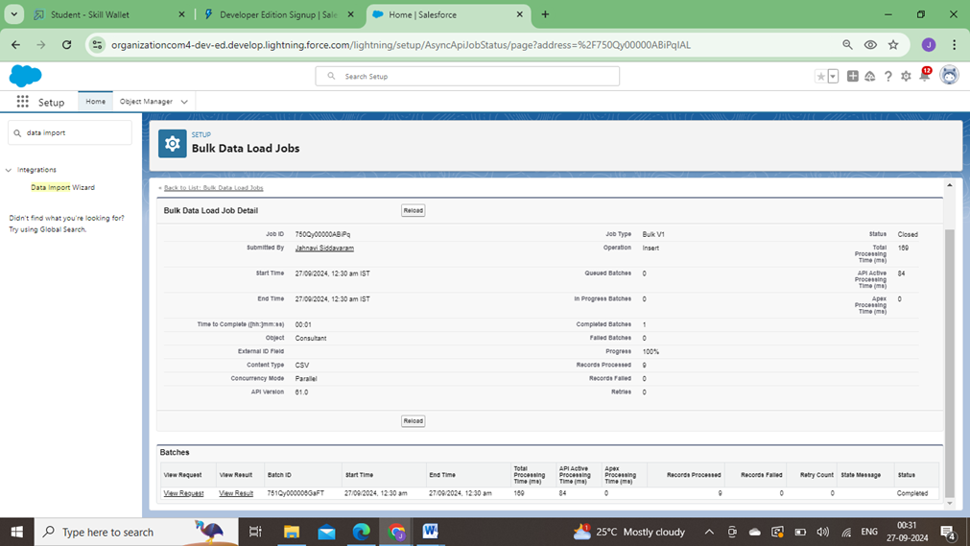

Make sure you have 0 recordsunder the records failed column.

**Note** - Do Field mappingcarefully.

**11.What are Reports?**

# Reports:

Reports in Salesforce is a list of records that meet a particular criterion which gives an answer to a particular question.These records are displayed as a table that can befiltered or grouped based on any field.

There are 4 types of report formatsin Salesforce:

**Tabular Reports**:

This is the most basic report format. It just displaysthe row of records in a table with a grand total. While easy to set up they can’t be used to create groups of data or charts and also cannot be used in Dashboards. They are mainly used to generate a simple list or a list with a grand total.

1. **Summary Reports**:

It is the most commonly used type of report. It allows groupingof rows of data, view subtotal, and create charts.

1. **Matrix Report**:

It is the most complex report format. Matrix report summarizes information in a grid format. It allows records to be grouped by both columns and rows. It can also be used to generate dashboards. Charts can be added to this type of report.

1. **Joined Reports**:

These types of reports let us create different views of data from multiple report types. The data is joined reports are organized in blocks. Each block acts as a subreport with its own fields, columns,sorting, and filtering. They are used to group and show data from multiple report types in different views.

# Report types:

Report type determines which set of records will be available in a report. Every report is based on a particular report type. The report type is selectedfirst when we create a report. Every reporttype has a primary object and one or more related objects. All these objects must be linked together either directly or indirectly.

* 1. A report type cannot includemore than 4 objects.
  2. Once a reportis created its report type cannot be changed.

There are 2 typesof report types:

1. **Standard Report Types:**

Standard ReportTypes are automatically included with standardobjects and also with custom objects where “Allow Reports” is checked.

Standard report types cannot be customized and automatically include standard and custom fields for each object within the report type. Standard report types get created when an object is created, also when a relationship is created.

**Note:** Standard reporttypes always have inner joins.

1. **Custom Report Types:**

Custom report types are reporting templates createdto streamline the reporting process. Custom Reports are created by an administrator or User with “Manage

1. **Custom Report Types”permission**. Custom report types are created when standard report types cannot specify which records will be available on reports.

In custom reporttypes we can specify objects which will be available in a particular report. The primary object must have a relationship with other objectspresent in a report type either directly or indirectly.

There are 3types of access levels of folders:

* 1. **Viewer:**

With this access level, users can seethe data in a reportbut cannot make any changes except cloning it into a new report.

* 1. **Editor:**

With this access level,users can view and modifythe reports it contains and can also move them to/from any other folders they have access level as Editor or Manager.

* 1. **Manager**:

With this accesslevel, users can do everything Viewers & Editorscan do, plus they can also control other user’s access levels to this folder. Also, users withManager Access levels can delete the report.

**11.1.Create Report**

* + 1. Click App Launcher
    2. Select Urban Color App
    3. Click reportstab
    4. Click New Report.
    5. Click the report type as Consultants Click Start report.
    6. Customize your report, in Columns select – Consultant Name, Delivery type, Products, Payment.
    7. Click on the drop down optionon the payment column and select Bucketthis column.
    8. Bucket Name as Paymenttype
    9. Click on Add Bucketand name it as NetBanking
    10. Click on Add Bucketand name it as Cash
    11. Now Clickon All Values and selectCredit Card, Debit Card, UPI and Move to Net Banking.
    12. Now Click on All Values again and select Cash and Move to Cash.
    13. Click on Apply.

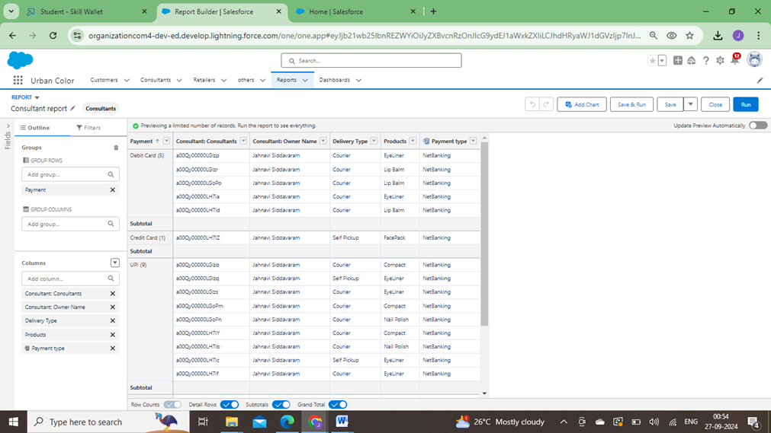

14. In Group Rows Add PaymentType Bucket Field.

15. Click refresh

16. Click Save and Run

17. Give report name – Consultant report

18. Click Save.

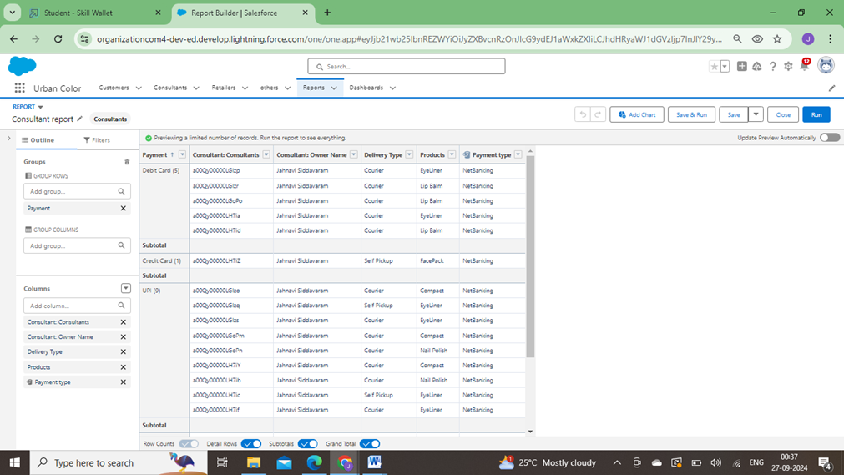

**11.2.ViewReport**

* + 1. Click on App Launcher on the left side of the screen.
    2. Search Urban ColorApp & click on it.
    3. Click on Reports Tab.

Click on Urban Color Report and see record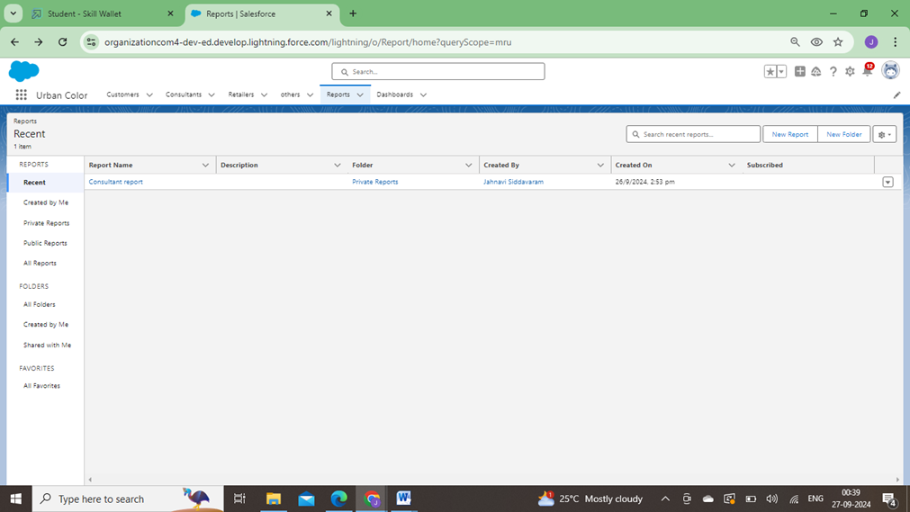

**12.Dashboards**

Dashboards let you curate data from reports usingcharts, tables, and metrics. If your colleagues need more information, then they're able to view your dashboard's data supplying reports. Dashboard filters make it easy for users to apply different data perspectives to a single dashboard.

**12.1.Create Dashboard**

* + 1. Click on the Dashboards tab from the Urban Colorapplication.
    2. Click on the new dashboard.
    3. Give name- Consultant Dashboard
    4. Click create
    5. Give your dashboarda name and click on +component
    6. Select the Consultants Report which you created.
    7. For the data visualization select any of the chart, table etc. as per your choice/requirement.
    8. Click add.
    9. Click save.
    10. Click save.

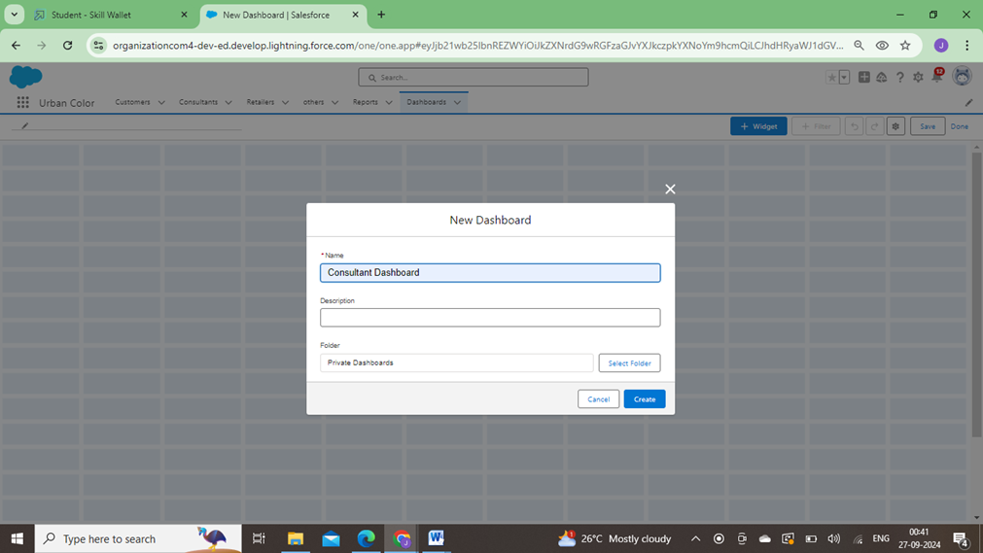

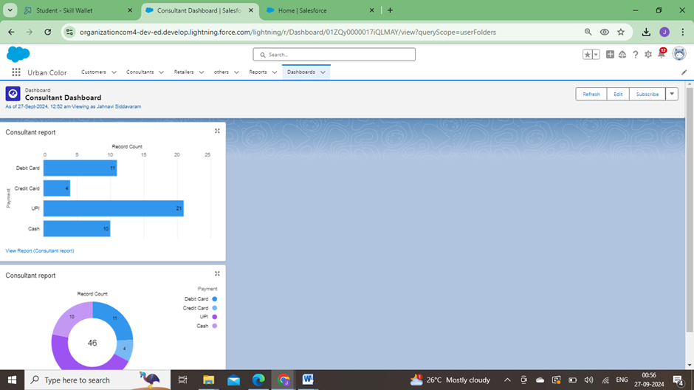

# 12.2.View Dashboard

* + 1. Click on App Launcher on the left side of the screen.
    2. Search Candidate InternalResult Card & click on it.
    3. Click on Dashboard Tab.
    4. Click on Candidate Internal Result Card see graphview of records

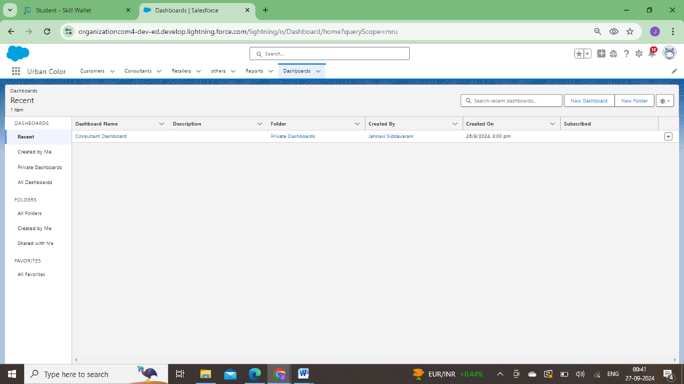

**CONCLUSION**

The development of the **Cosmetics Store Management** project on Salesforce was a valuable learning experience. Understanding the business needs, such as managing inventory, handling customer data, and automating order processing, was the first step. By working with Salesforce’s core features—like custom objects, workflows, and automation tools—I learned how to configure and tailor the platform to meet these specific requirements. Additionally, exploring data migration and integration with external systems, such as payment gateways, presented challenges that were solved through research, trial, and collaboration with Salesforce resources.

Problem-solving was a key aspect of this project. Each challenge, from configuring complex relationships between custom objects to ensuring accurate inventory tracking, required breaking down tasks and testing them iteratively. By leveraging Salesforce’s capabilities and following best practices, I was able to implement solutions that streamlined operations for the store. The experience deepened my knowledge of Salesforce CRM and improved my skills in applying cloud-based tools to solve real-world business problems efficiently.